File Allocation Table (FAT) is a file system that was developed by Microsoft to support small disks and simple folder structures. The file system is named File Allocation Table because it uses a table to track the clusters on a storage volume, as well as how those clusters are linked together through their associated files and directories. Because of the table's important role, the acronym FAT is sometimes used to refer to the table itself, rather than the file system, although it's not uncommon to see it used both ways in a single resource.
… FAT (File Allocation Table) uses a variation of linked allocation…

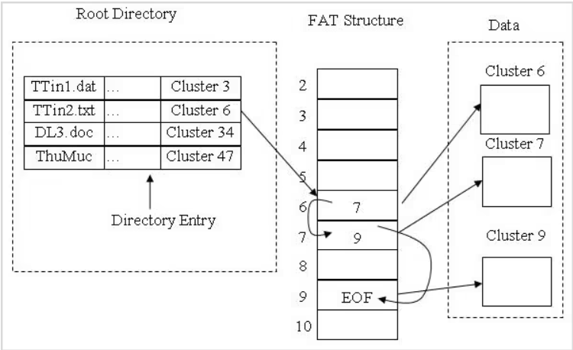

Link para FAT16 etc: https://www.sciencedirect.com/topics/computer-science/file-allocation-table

